Chapter 9 Exception Handling

- Exception: some type of error
- throwing an exception: mechanism that signals when something unusual happens
- handling the exception: code that deals with the exceptional case
- event-driven programming
  - objects are defined so that they send events(objects) to other objects that handle the events
  - firing an event: sending an event
- syntax example:

try {
/* 重點：
1. 如果這個block有error，會中斷，並立即執行以下對應的catch block

2. 如果在這裡有error，需要用if-else statement檢查是哪一種error，
再寫throw Exception，使以下catch block接收

3. 如果在這裡執行的method有error，而且該method可回傳throw
Exception，就不需要寫if-else statement來throw Exception了
，會對應到下面Exception類別自動catch
*/
} catch (MyExceptionType myExcept) {
//MyExceptionType為開法者自物件類別
//myExcept為reference指向MyExceptionType物件
} catch (Exception otherExcept) {
//Exception為Java原始物件類別
} finally {
/* 重點：
1. 無論有無exception，前面的block執行完，最後這裡永遠都會執行

2. finally block在try-catch結構中可省略
*/
}

- 使用try-catch重點：
  - 不會明確知道try block哪一行出問題，因為到底哪一行出問題不重要
  - 若在try block呼叫的method可回傳throw Exception，就可以省去在try block內寫一大堆if-else的檢查機制
  - catch block只有遇到錯誤才會直行。執行完後會立即執行finally block
  - finally block可省略，並非必要的。finally block無論有無錯誤都會執行

- ArrayIndexOutOfBoundsException example

public class HelloException {
public static void main(String[] args) {
int i=0;
String greetings[] = {
"Hello world!",
"hello",
"world",
};

while(i<4){
try{
//不需要寫if-else，超出範圍直接catch
System.out.println(greetings[i]);
i++;
} catch (ArrayIndexOutOfBoundsException e){
System.out.println("catch");
break;
} finally{
//無論有無錯誤都會執行
System.out.println("Always printed");
}
}
}
}

- self-defined example

//derived from Exception
public class DividedByZero extends Exception {
public DividedByZero(){}

public DividedByZero(String message){
super(message);
}
}

public class Test {

//func會可回傳throw DividedByZero Exception，所以try-catch可
//以不用寫if-else
public static int func(int x, int y) throws DividedByZero{
if(y == 0){
throw new DividedByZero("divided by 0");
}
return x/y;
}

public static void main(String[] args) {
int a = 0;
int b = 0;

//真正要用try catch應該在這裡，而非在func內部
//func會throw exception，如果在這裡不寫try-catch會有
//warning
try{
func(a,b);
} catch (DividedByZero e){
//Exception class有data member存取error message
System.out.println(e.getMessage());
}
}
}

- Exception Controlled Loops，例如：網路連線會不斷地試圖連線

boolean done = false;
while (! done) {
try {
CodeThatMayThrowAnException
done = true;//execute only when there is no exception
} catch (SomeExceptionClass e){
SomeMoreCode
}
}

- Exception Classes from Standard Packages(java.lang package)
  - for example: Exception, IOException, NoSuchMethodException, FileNotFoundException
    - Exception has getMessage method
      - there is a String arguement in the Exception constructor
  - more info: http://docs.oracle.com/javase/7/docs/api/java/lang/Exception.html
- Other Exception Classes should be imported from java.io.IOException
- multiple catch blocks
  - when catching multiple exceptions, catch the more specific exception first
  - when an exception is thrown in a try block, the catch blocks are examined in order, and the first one that matches the type is executed
  - for example:
public static int func(int x, int y){
boolean fail = true;
try{
if (y == 0)
throw new MyException("divided by 0");
if (fail == true)
throw new MyException2("fail boolean");
} catch (MyException e){
System.out.println(e.getMessage());
System.exit(1);
} catch (MyException2 e){
System.out.println(e.getMessage());
} catch (Exception e){//越general的exception寫越後面，
//以免會接收了所有Exception的繼承者
System.out.println(e.getMessage());
}
return x/y;
}

- throwing an exception in a method
  - 請見重點9
  - if a method can throw more than one type of exception, separate the exception types by commas, for example:
public void aMethod() throws AnException, AnotherException
  - 以上AnException和AnotherException具備covariant特性，故可以回傳其derived class

- Catch or Declare Rule
  - only two techniques to catch
    - try block throws an exception, and catch block catches the possible exception within the same method
    - possible exception is declared at the start of the method definition, and returns a “throw exception” if error occurs (throwing an exception in a method)
  - both techniques can be mixed
- checked exception: errors that occur in a correct program
  - Exception, Throwable, and all descendants of Exception deals with such errors
  - must use Catch or Declare Rule
- unchecked exceptions: fatal errors
  - fatal situations: Error and its descendant classes deals with such errors
  - not subject to the Catch or Declare Rule
  - case example: memory space not enough
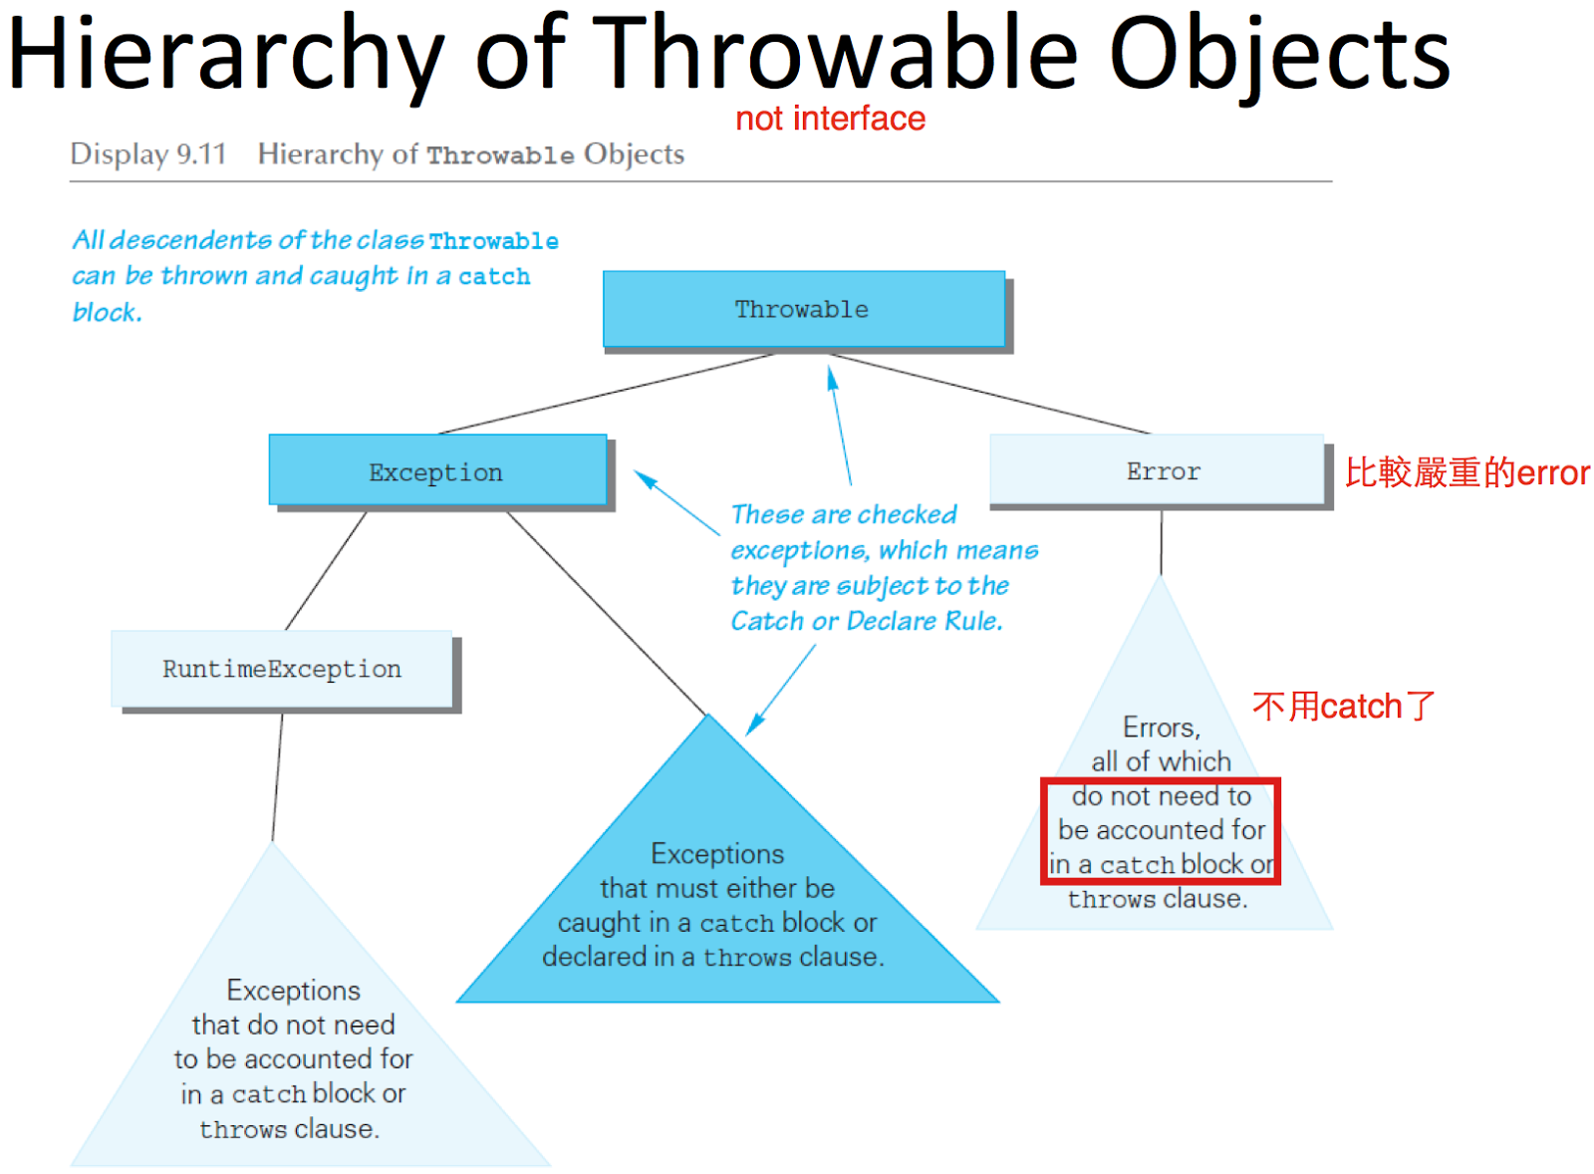

- Nested try-catch blocks
  - try-catch block in catch block
    - must use different names for catch block parameters in inner and outer blocks
  - try-catch block in try block
    - if an exception is not caught in the inner block, then it will be thrown to the outer block
- Rethrowing an Exception
  - catch block has code that throws an exception
  - sometimes catch an exception, and check getMessage, and then thrown to somewhere else
- main method可以加上throw
  - for example:
public static void main(String[] args) throws Exception
  - compile的時候不會出錯，但是runtime時候會出錯

